**Python Class – 5**

1. You have to print only "Loading....." in animated form.

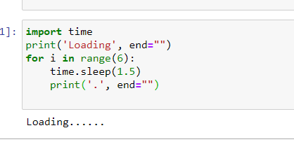

2. Difference between Return and Yield ?

The yield statement suspends function’s execution and sends a value back to the caller, but retains state so function resumes where it is left off. Hence, the code produces a series of values over time, rather than computing them at once and sending them back like a list or a tuple. Yield are used in Python generators.

Return sends a specified value back to its caller.

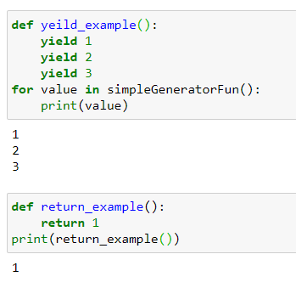

3. Make digital Clock and run it for 5 sec.

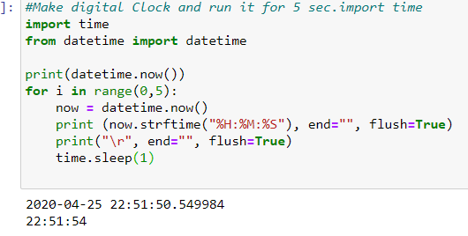

4. Add anything in tuple.. example: (1,2,3,4) -> new tuple (1,2,3,4,5)

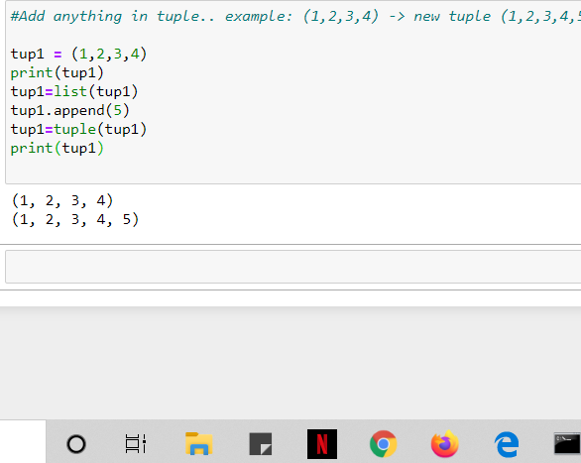

5. WhatsApp texting using webbrowser Lib.

